Solution Design Document

Reference: ERM000000321858
Title: OneTrust for Aida (GDPR) Author: M. Rijkers
Date Issued: 27-09-2017

A privacy management solution for GPDR

The purpose of this document is to outline the recommended solution, estimated costs and approach. The solution, costs and approach are subject to change depending on changing scope or requirements, or changes to AGT’s service offerings and rates. This document does not initiate a project or piece of work for AGT.

Contents
1. Contents 2
2. Revision History 3
3. Distribution of this Document 3
3.1 Primary Distribution 3
3.2 Secondary Distribution 3
3.3 Solution owner 3
4. Summary 4
4.1 User Story 4
4.2 Background 4
4.3 Goal 4
4.4 Scope 5
4.5 Solution 6
4.6 Service description 6
4.7 Hosting 6
4.8 Requirements for Implementation 7
4.9 Data flows 8
4.10 Operational Model (SDLC) 8
4.11 Other requirements 8
5. High Level Architecture Overview 9
6. Infrastructure Breakdown 10
6.1 Service List 10
7. Assumptions and Risks 11
7.1 Assumptions 11
7.2 Risks 12
8. Estimated Costs 13
9. Recommended Approach 14
9.1 Classification 14
9.2 Reviews 14
9.3 High Level Activities 14
9.4 Proposed Level of Coordination 14
9.5 Desired Start and End Dates 14
10. Architectural Alignment 15
10.1 Summary 15
10.2 CB Design Patterns 15
10.3 Exit Strategy 15
10.4 Disaster Recovery Strategy 15
10.5 Global IT Principle Alignment 15
11. Appendices 18
11.1 Solution Design 18
11.2 Solution Design Diagram 18
11.3 Cloud Brokering and Solution Design Checklist 18
11.4 Radiant Domain List for scope 18
11.5 EDC Proxy Usage 18
11.6 OneTrust Application Architecture 19
11.1 Detailed scope per country 20

Revision History

Version | Author/ Reviewer |  | Date Issued: | Summary of Changes: | Changes Marked
0.1 | M. Rijkers | 18-08-2017 |  | n.a. | n.a.
0.2 | M. Rijkers | 07-09-2017 |  | 2nd review | n.a.
1.0 | M. Rijkers | 27-09-2017 |  | Final Version, added detailed scope in Appendix | -

Distribution of this Document

A copy of this document has been issued to those shown below and any updates will be
circulated only to these individuals.

Primary Distribution

Recipient | Area of Responsibility
Marco de Knegt | PMO Aegon Group
Frans Weijdener | GITO
Ian Litler | Corporate Center
Tammy Price | GSS Business Support
Reynald Nijhove | GITO Program Manager
Stacy Rosenberger | Sr Mgt ORIC
Mark Oehler | AGT WF Mgt
Kevin Adair | AGT Platform Management
Don Crask | AGT Identity Management

Secondary Distribution
This Design Document is circulated to those in the secondary distribution for information only.

Recipient | Area of Responsibility
AGT Cloud Brokering and Solution Design | Peer review
AGT Local Design Authority | Architecture review
Ryan Basu | AGT Engagement team - Product Owner
Matt Hutchins | AGT Engagement team - Scrum master
Bobby Willoughby | AGT Network Services
Ryan DeVries | AGT Security
Bobby Willoughby | AGT Network Services

Solution owner

Owner | Business Unit | Cost Center
Sebastiaan ter Wee | Corporate Center / Aegon Group | KP345- Project code I112

Summary

User Story

As a business user I want to register European privacy Regulations / GDPR data in a corporate solution to replace Excel sheets and administration.

Background

Regulation (EU) 2016/679 is a regulation by which the European Parliament, the Council of the European Union and the European Commission intend to strengthen and unify data protection for all individuals within the European Union (EU). For the Aida program, with which Aegon will implement the new European privacy Regulation (GDPR, 25 May 2018) and a common data transfer framework called Binding Corporate Rules (BCR), we are in the process of procuring a cloud solution that eventually needs to be made available within Aegon. GDPR is the set of rules while BCR adds the governance.

The cloud solution GDPR Compliance of OneTrust will be used to perform a data inventory, risk assessment, legitimization, Privacy Impact Assessment (PIA) and Data Protection Impact Assessment (DPIA) for all processes containing customer or employee data.

Goal

Currently Excel sheets are being used to register information. This becomes unmanageable and can be solved adopting a tool. The goal is to implement a new solution to support new European privacy Regulations (General Data Protection Regulation (GDPR) per 25 May 2018).

The desire is make this a GSS supported solution.

Scope
The SaaS cloud solution of OneTrust needs to be made available within Aegon, ACE and CEE. Business users are around 50 DPO (Data Protection Officers) from the business units. The scope of this design is a secure connection to the SaaS provider.

Aegon - Aegon Global Technology, Aegon Asset Management and Corporate Center

ACE (Aegon Central Europe) Business Units involved in the Aida program are:
Netherlands, UK, Ireland, Czech Republic, Hungary, Poland, Romania and Slovakia.

CCE (Central East Europe) Business Units involved in the Aida program are: Spain and Turkey.

Countries can have multiple divisions listed. See Appendix xx for more details.
Portugal is not in scope for AIDA. Ireland will be in scope of the OneTrust project. Ireland will buy their own instance in 2018.

During implementation we will start with AGT supported countries NL and UK

Solution
The new EU General Data Protection Regulation (GDPR) requires organizations to undertake significant operational reform to meet the increased obligations of handling personal data. Appropriate record keeping is critical as the GDPR requires organizations to demonstrate compliance and accountability. The OneTrust privacy management software platform helps organizations meet these GDPR requirements by automating Privacy Impact Assessments and data mapping, identifying privacy risks, and enforcing risk management activities in an integrated platform. The modules Assessment Automation and Data Mapping are being used.

Service description
OneTrust is the supplier hosting the solution for this. Access will be enabled with AD federation to authorized employees of AEGON business units in scope.
Currently employees of AEGON units do not make use of this services. It is web based and located in the provider’s data center. The connection is from a workstation, via the proxy server to the web server of the provider, via MPLS or public Internet connection. The application supports SAML tokens for the authentication with SSO that is used for different SDLC stages/websites.

In case of long term disruption of the service AEGON will have to fall back on alternative (less or non-automated) sign-up processes, which will be labor intensive and will involve additional costs.

Hosting

The solution is hosted in the US and the UK in Microsoft Azure data centers. For this project we will leverage the Frankfurt region. We need only port 443 (HTTPS/TLS1.2). Secure LDAP is supported. Authentication and authorization for applications will be routed through SAML2.0 or oAuth tokens. Ping federate is supported to facilitate this.

See vendor https://onetrust.com/

Requirements for Implementation

We need the following conditions to enable secure communication with single sign-on to the SaaS provider.

- Secure network connections to AEGON’s WAN backbone via Open borders MPLS
Circuit for the CEE countries is a part of the integration project. This means new circuits are being added in all European Office to have them connect to the new EDI MPLS into Edinburgh. If the project is not able to provide the secure connections in time these alternatives apply:

- Provide temporary manual login to SaaS Solution
- Use a VPN client or VDI solution, Citrix (requires ds-domain registration)

- Use of EDC proxies for internet access

All countries are making use of the EDC proxies for internet access, but may also be maintaining a local egress for limited server access or situations where a geo-located source IP is required. Via Open Borders a few countries have limited services allowed for things like AD trust and SharePoint, but are typically not accessing other resources internally. If this prevents SSO being enabled, users will be prompted for the Aegon User ID and Password by the Ping Federation UI.

Timelines vary for the countries depending on their integration path. If we are able to connect new users via VPN client that could provide a temporary solution. The traffic to the SaaS vendor would then route out via the EDC proxy servers.

- Countries/AD Domains need to be setup in Radiant Logic (AGTs Federated Identity management Service)

Appendix 11.5 lists countries/AD domains that are already set up in Radiant Logic. This is an important requirement to enable SSO for any SaaS solution.

Alternative solutions:

- If users are not registered in federated domains we can consider registering them twice until AD migrations are completed (DS domain).

- Even if they are not in Radiant we basically need port 389 and 636 opened via the firewall to their DC’s and a support account that will allow us to authenticate to their domain.

- We can use the Azure AD user repository for authentication. This option doesn’t deliver a SSO experience. User needs to submit corporate username/password.

Preferred solution selected by LDA/SAB:

- Egress Internet traffic should route through EDC proxies

- Authentication via Open Border into Radiant Logic (single identity provider repository)

- Authorizations via AD groups

Data flows

The end user will start Internet Explorer and will browse to https://{hostname}. Based on the content of the Proxy Auto Configuration (PAC) file, the bowser will connect to the proxy in the EDC The proxy will resolve the website to an IP-address and try to connect. The IP-traffic for this server will be routed via the proxy over public internet to the service provider datacenter location. Security tokens (SAML) make sure the user is not prompted for authentication.

In case of a connection by Open Borders, the browser of that user will connect to https://{hostname} and from here the same flow as described above will be followed.

Operational Model (SDLC)

Default three stages will be used:

- Beta software testing / validation
- User Acceptance Testing
- Production / Live

Other requirements

Other requirements for the SaaS application are:

- Exit Strategy: export all data in industry format
- Data Retention: Archiving / 5 years
- Disaster Recovery: RPO 12, RTO 24
- Exit Strategy: export all data in industry format

High Level Architecture Overview

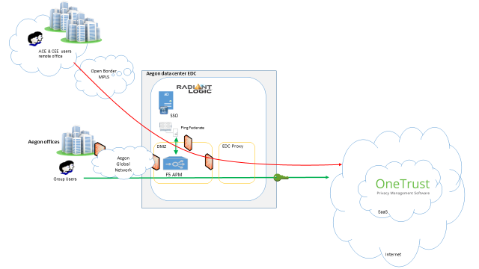

Infrastructure Breakdown

Service List

Component | Requirements | Additional Details
Cloud Account
Virtual Network
Azure App Service
Database
Firewall
Network | Internet connectivity to SaaS | HTTPS port 443
File transfer
Storage
Mainframe
Webhosting
SharePoint
Messaging | SMTP | outbound only
Data Security
Client Security | AD Groups
Identity Management | SSO Federation via Ping

Assumptions and Risks

Assumptions
This section details any assumptions or caveats which have been made when creating the solution design and cost estimate

Title | Assumption | Impact | Owner
Requirements | That the key business requirements have been fully communicated to AGT | If the requirements are not complete, or change, then the design or cost of the solution will change | Sebastiaan ter Wee
Overview Solution | That the business accepts this as an overview solution and high level cost estimate which is non-binding and open to review dependent on changes to requirements or services | The solution design and cost estimate are subject to change as new information becomes available and the solution and costs are refined | Sebastiaan ter Wee
3rd Party Vendor | We assume the Risk Assessment has been completed before implementation | If not completed, then the design or solution will not pass LDA/SAB | Sebastiaan ter Wee
Procurement | AGT has been involved | - | Sebastiaan ter Wee
ISO | Local ISO has been involved | - | Sebastiaan ter Wee
PIA | Assessment has been completed | If not completed, then the design or solution will not pass LDA/SAB | Sebastiaan ter Wee

Risks
This section details any risks which should be noted with the solution hosting

Title | Risk | Mitigation | Owner
Backup | The risk of not having a | See provider contract | Sebastiaan ter Wee
Disaster Recovery | Unacceptable outage or service unavailable for a long period of time | See provider contract | Sebastiaan ter Wee
High Availability | Service having a low availability | See provider contract | Sebastiaan ter Wee
Backup out plan | Risk of not having a proper exit or back-out plan | Export data to CSV or other industry standard format | Sebastiaan ter Wee
Network Requirements | Risk that network connectivity for countries in scope does not meet the requirements outlined | Speed up onboarding or allow temporary manual login | Sebastiaan ter Wee
Risk | The SaaS solution is a multi-tenant hosted solution | SaaS provider needs to mitigate hosting risks. This should be an outcome of the Technology risk assessment. | Sebastiaan ter Wee

Estimated Costs

This is an estimate of the likely cost of the solution, based on the known scope and requirements. This cost contains an estimate of the man-power effort required to implement the solution, and the ongoing annual running cost of the solution. This is not a quote and is subject to change if new information becomes available, the scope or requirements change, or if AGT’s service offerings and rates change.

Implementation on off costs:
Costs AGT Network Team 20 hours
Costs AGT IM team (SSO/AD) 40 hours
Ongoing operational costs are estimated 10 hours per month (info: Tammy Price / Edmond Boon for final GSS support estimation) – TBD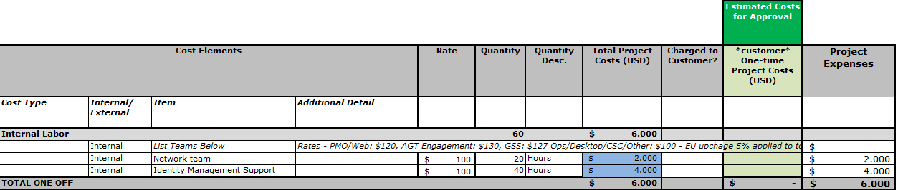

Recommended Approach
Please specify the data sources, data fields, and their classification

Classification

Classification | Y/N
PII Personally Identifiable Information (Login employee information) | Y
PHI Protected Health Information | N
PCI Payment Card Industry | N
HIPAA Health Insurance Portability and Accountability | N
PIA/GDPR EU personal data regulations | Y

Reviews

Review | Y/N
Privacy Impact Assessment (PIA) | Covered
Security Risk Assessment (ORIC) – DNB Risk Assessment | Running
Security Review (ISO) – Global Security | Done
Legal /Risk (Local) – DNB Risk Assessment | Running
License Management / Procurement | Running
Technology Risk Assessment | N

High Level Activities

Assist with configuration of PKI/certificate servers
Assist with secure network connections
Assist with Identity Access Management and SSO configurations

Proposed Level of Coordination

- Coordination with AGT launch tickets and handover and inform AGT PMO
- Coordination with AGT support tickets (Launch) for firewall changes, DNS registrations and PKI Certificate(s)
http://launch.us.aegon.com/kinetic/DisplayPage?name=Launch

Desired Start and End Dates
The cloud solution will be used in the program to enable Aegon to become GDPR compliant and file for BCR. For the OneTrust cloud solution we are currently in the process of contract negotiations. We expect to have a signed contract by the mid of September.
Expected end date of the OneTrust implementation will be January 2018.

Architectural Alignment

Summary
All systems, versions, and configurations are within AGT supported architecture and versions at the time of this document creation.

CB Design Patterns
Link to design pattern library
Cloud Standard Architecture | Link

Exit Strategy
Export data into Industry standard format, backup on site.

Disaster Recovery Strategy
n.a.

Global IT Principle Alignment
Please indicate the alignment on the chart below using a RAG status. Green being “Aligns” and red being “Does Not Align.” Please see the Global IT Principles, Rationale, and Implications.
No. | Principle Statement | RAG* | PSA Alignment
GP01 | Re-use what we already have, where essential business requirements are met | N/A
GP02 | Acquire before build, but build for differentiation, stay within bounds of the core functionality of the solution | Y
GP03 | Base decisions on business need balanced with long-term costs and benefits, start with clear requirements then look for solutions | Y
GP04 | Ensure innovation is leveraged to differentiate ourselves and sustain the customer experience | Y
GP05 | Ensure that the technical risk to the business is understood and handled appropriately | Y
GP06 | All IT solutions will have identified owners | Y
GP07 | Ensure that the people have the proper training, support, and skills necessary to architect, service, use and maintain the solution | Y
GP08 | For all hardware & software, the upgrade / release policy is to stay current | Y
PP01 | Procurement by Procurement | Y
PP02 | Procurement manages the entire lifecycle of the supplier/vendor relationships
PP03 | Aegon will use procurement tool(s) to enable efficient execution of the procurement process | Y
DP01 | Data access is auditable and secured | Y
DP02 | Use data governance and common data definitions to improve information reliability
DP03 | Information is to be shareable and made accessible, where required
DP04 | Utilize Data as a Strategic Asset
IP01 | Infrastructure solutions are designed to be scalable and flexible | Y
IP02 | All systems will have documented Service Level requirements with DR, HA and Support
IP03 | Production systems will adhere to Aegon infrastructure and configuration standards
IP04 | Security, Performance and Capacity Monitoring will be implemented for all production infrastructure
IP05 | All Infrastructure will be virtualized and cloud deployment is preferred | Y
OP01 | Ensure the architectural design obtains the maximum benefit for the cost | Y
OP02 | Applications, services and data with transactional purposes are separated from those with analytical purposes | Y
OP03 | Automate manual processes where it is cost effective and practical
OP04 | Design services as loosely coupled units of functionality that are self-contained with explicit boundaries
OP05 | Application interaction is Service-Based | Y
OP06 | Design a consistent user experience, independent of device | Y
OP07 | Design for Cloud-First and Agility | Y
SP01 | Customer and business information is continually protected and defended in line with its value, risk and regulations
SP02 | The customer and business can rely on the integrity and availability of their information throughout its lifecycle
SP03 | Information security enables business innovation by matching and adapting controls to stay within business risk tolerance
SP04 | Information threats and exposures are regularly evaluated assuring the alignment of the security control framework
SP05 | Customers and employees are aware of information security risks and controls and understand their role to safeguard
UP01 | The end user experience is positive, engaging, and empowering in all distribution and communication channels | Y
IM01 | Maintain Separation of Identity and Access Management (IAM) functionality from applications | Y

Appendices

Solution Design

Link

Solution Design Diagram

Link

Cloud Brokering and Solution Design Checklist

Link

Radiant Domain List for scope

Domain Label | LDAP Type | Domain | Port
CZ | AD2008 | czdc01.ad.aegon.cz | 636
DS | AD2008 | crdsdc01.ds.global | 636
HUNGARY | AD2008 | budsdc101.hu.emea.aegon.com | 636
NL | AD2008 | crnldc01.nl.aegon.com | 636
POLAND | AD2008 | euplad0003.aegonpolska.pl | 389
ROMANIA | AD2008 | srvadir02.btaegon.ro | 636
SLOVAKIA | AD2008 | wad03.aegon.sk | 636
SPAIN | AD2008 | aegspdc001.aegondg.es | 389
TURKEY | AD2008 | aegontrdc3.aegontr.local | 636
UK | AD2008 | crukdc01.aegonuk.com | 636
UKRAINE | AD2008 | kiedc02.fidem.loc | 636
US / Ireland | AD2008 | crdcusdc01.us.aegon.com | 636

EDC Proxy Usage
Country | EDC Proxy | Radiant
Netherlands | Yes | Yes
Czech Republic | October | Yes
Hungary | November | Yes
Poland | October | Yes
Romania | Before 2018 | Yes
Slovakia | Before 2018 | Yes
Spain | Yes | Yes
Turkey | Yes | Yes

OneTrust Application Architecture

The following architecture show on-premises IAAS and is not applicable for SAAS.

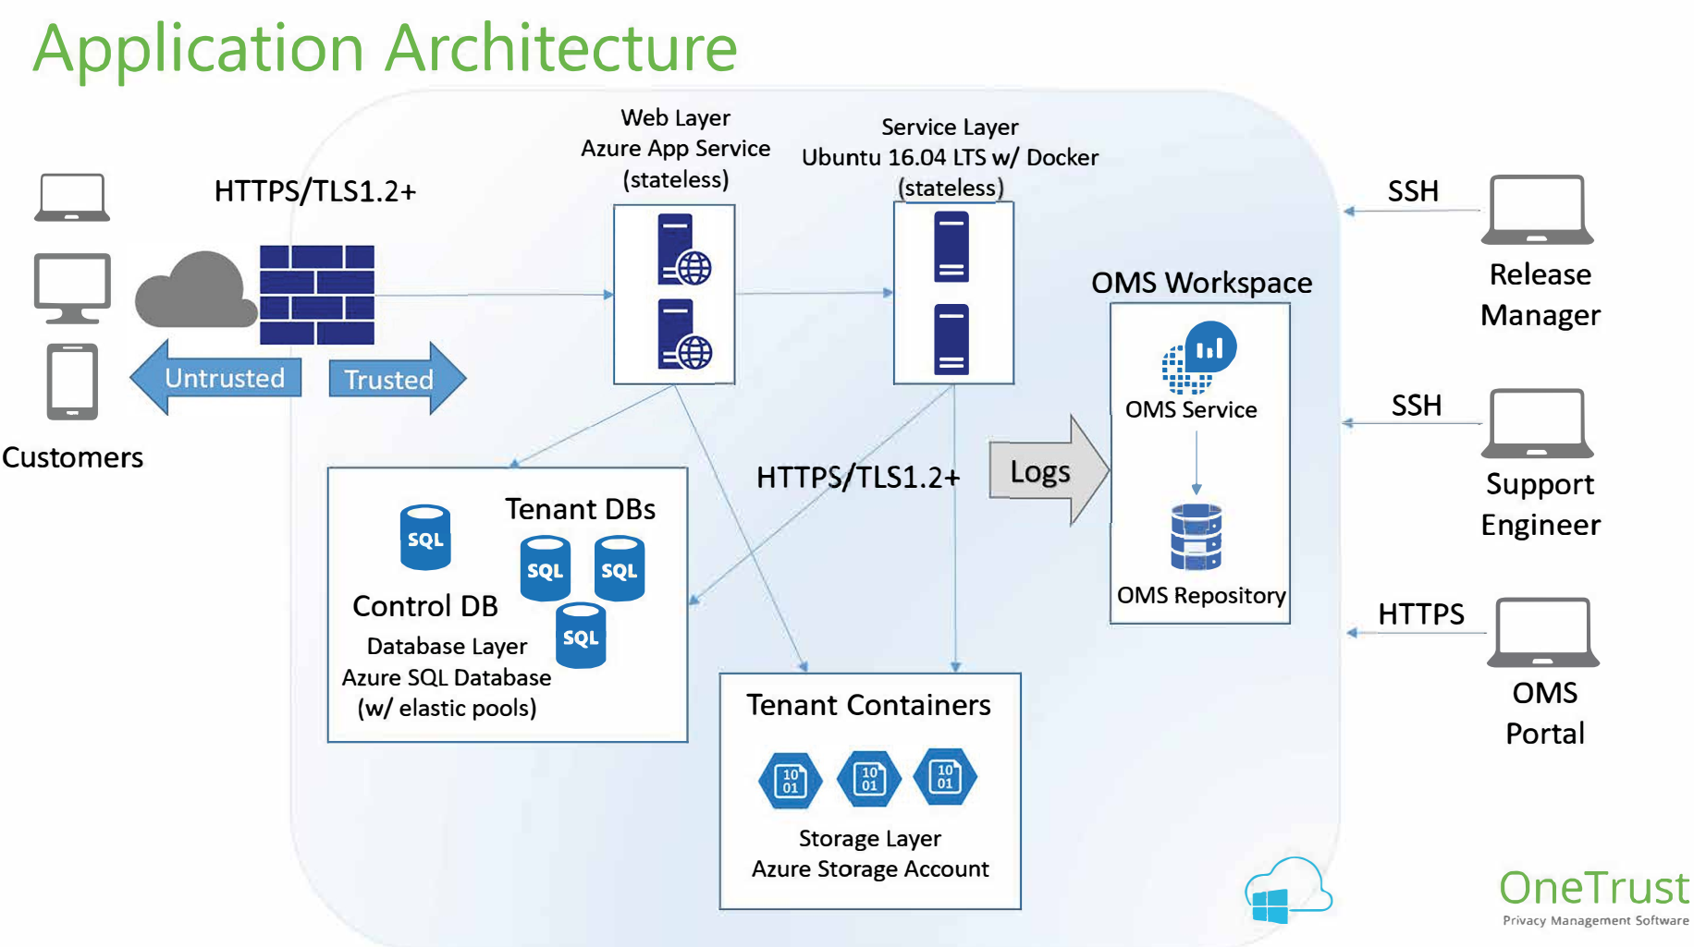

Detailed scope per country

Entity |  | Base Location | AGT -Supported
AAM NL |  | CEE | Yes
Aegon NL |  | CEE | Yes
Aegon UK |  | UK | Yes
Aegon UK ADMS |  | UK | Yes
Aegon UK CoFunds |  | UK | Yes
AGT |  | CEE | Yes
AGT |  | UK | Yes
Caresco * |  | CEE | No
Corporate Center |  | CEE | Yes
Czech Republic |  | CEE | No
Hungary |  | CEE | No
Ireland - future divesture |  | UK | Yes
Kames |  | UK | Yes
Knab |  | CEE | No
Nedasco (BeSuitable) |  | CEE | No
Poland |  | CEE | No
Romania |  | CEE | No
Slovakia |  | CEE | No
Spain |  | CEE | No
TKPi |  | CEE | Yes
TKPp |  | CEE | No
Turkey |  | CEE | No

* unknown if this is in scope

